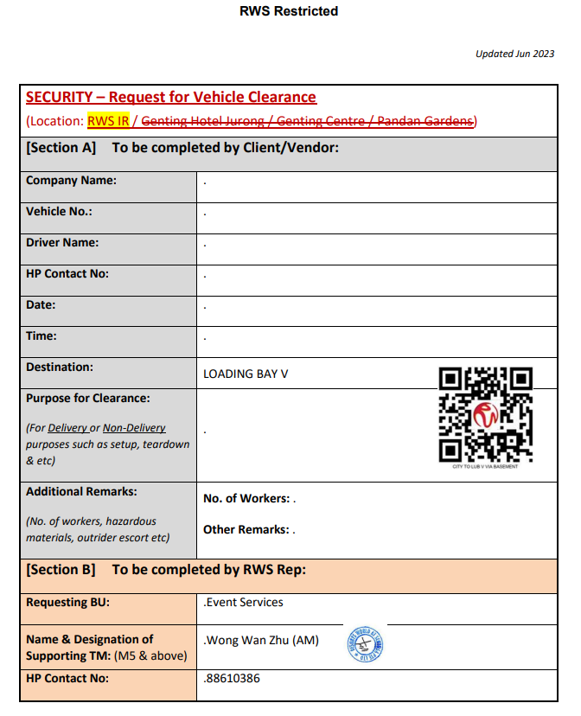
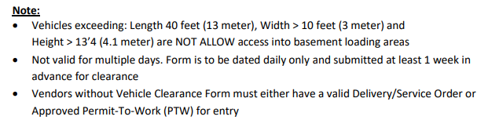
IMPORTANT FOR IDENTIFICATION OF YOUR COURIER ONSITE – EXHITIBITION MATERIALS LABEL FOR EACH BOX
In order to identify your boxes sent by your courier onsite, please ensure that EACH BOX is labeled with the following:
DELIVERY LABEL

Equarius Hotel, Resorts World Sentosa
Address: 8 Sentosa Gateway, Equarius Hotel, 098269

Attn to: Wan Zhu (Ms), MICE Event Services
LOADING BAY V
Equarius Hotel – Equarius Ballroom Level 2
D : +65 6577 9966 | M : +65 8861 0386
20th & 21st August 2024, Equarius Ballroom, Level 2

Items: ___________________________of _____________________________

Contact Details of sender: ________________________________________
Company Name: ________________________________________________
Contact Name: __________________________________________________
Contact Number: ________________________________________________

